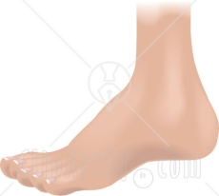
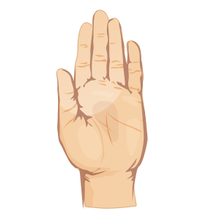
Local Steroid (Joint) Injection Information Sheet

Introduction
If you have an inflamed or swollen joint, or if you have pain or inflammation near a joint, your doctor may inject a steroid preparation into the affected area. It is known as a local injection because it acts only in that area.
What steroid preparations are available?
There are several steroid preparations and your GP will choose the preparation and the dose most appropriate to your needs. The mildest is hydrocortisone. Prednisolone, methylprednisolone and triamcinolone are stronger and tend to be less soluble, remaining in the joint for longer. Benefit from the stronger drugs is associated with a slightly increased risk of local side-effects.
Your doctor will also decide whether to inject a local anaesthetic at the same time. This does not reduce inflammation but will allow almost immediate temporary pain relief.
Why has this treatment been recommended for me?
The injection is given to reduce inflammation, swelling and pain within a joint. Although osteoarthritis is mainly a ‘wear and tear’ condition, steroid injections are often given for this as well. This is because there is often some inflammation present and pain and swelling may be reduced.
A peri-articular or soft tissue injection is given to reduce pain and inflammation at that site, e.g. if you have tennis elbow your doctor may inject the tender area.
Do I need to rest after the injection?
It is often recommended to rest a weight-bearing joint such as the knee, hip or ankle as much as possible for the first 1-2 days after an intra-articular injection. If this is impractical then it would be sensible to avoid strenuous exercise for the first 1-2 days.
If the injection worked how often can it be repeated?
There is general agreement that if an injection is very helpful, and other treatments are either inappropriate or less effective, then the injection may be repeated every 3-4 months. However, there is a small risk of frequent injections causing cartilage damage, especially in weight-bearing joints such as the knee.
How long will the steroid injection take to work and how long will it last?
This depends to some extent on the preparation used. The short-acting soluble steroids give relief within hours and should last for at least a week. The longer-acting less soluble steroids may take a few days to become effective but may give benefit for 2 months of longer. If an anaesthetic has also been given, pain relief should occur within minutes but will usually wear off quickly (within half an hour, unless the anaesthetic selected is longer lasting). Many injections are quick and easy to perform and are associated with only minimal discomfort. Therefore local anaesthetic is not always used.
What are the possible risks or side-effects?
Side-effects are very unlikely. Very occasionally people notice a flare in their joint pain within the first 24 hours after an injection. This usually settles on its own within a couple of days. Very rarely an infection can occur. Therefore if the joint becomes more painful, hot and you start to feel unwell you should see your doctor immediately.
Occasionally with intra-articular and peri-articular injections some thinning or change in the colour of the skin may occur at the injection site. The risk of side-effects, particularly thinning of the skin, is greatest with the stronger preparations.
Local steroid injections may sometimes cause facial flushing or interfere with the menstrual cycle. Other steroid-related side-effects, seen with steroid tablets are rare unless injections are given frequently.
May I take other medicines along with steroid injections?
You may take other medicines with steroid injections. However, if you are taking a drug that thins the blood (an anticoagulant) such as warfarin, aspirin or clopidogrel, it is less likely that you will be offered an injection because of the risk of bleeding into the joint. If you are taking anticoagulants please mention this to the doctor giving the injection to ensure that s/he is aware of this.

To book an appointment please call 01905 744400 and request a 20 minute appointment with the following doctor: ……………………………

